BRUNEI

Brunei, a rainforest covered gem of a country nestled on the northern shores of the island of Borneo, is a refreshing tourist destination. It's not the largest country you'll ever visit, but pound for pound it is probably the richest
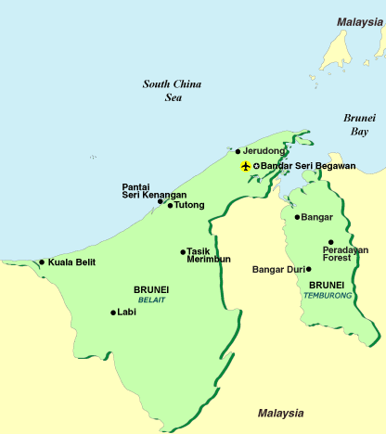

Brunei is a strict Muslim country, and the people of the nation live their lives accordingly. The country has banned the sale and consumption of alcohol, and appropriateness of dress and public behaviour is taken very seriously unlike in the Western world where pretty much anything is tolerated.

Visa : The visa is to be obtained prior to arrival in the country

Climate:
Weather's not much of a consideration when heading for Brunei - whenever you go it's bound to be warm and wet. September to January is the official wet season, when things are even warmer and wetter. Things tend to close down during Ramadan, when all Muslims must fast between dawn and dusk for a month, so it's worth checking if your visit will fall in this period.
Monthly Averages
 | Avg Low in °C | Avg Hi in °C | Avg Precip
January | 24° | 30° | 16.78 cm
February | 24° | 30° | 11.27 cm
March | 24° | 32° | 10.14 cm
April | 24° | 32° | 18.06 cm
May | 24° | 32° | 18.91 cm
June | 24° | 32° | 16.46 cm
July | 24° | 32° | 15.18 cm
August | 24° | 32° | 21.13 cm
September | 24° | 32° | 20.13 cm
October | 24° | 31° | 25.64 cm
November | 24° | 31° | 23.98 cm
December | 24° | 31° | 21.76 cm

Currency:
The currency in Brunei is Brunei Dollar (BND). However, other major currencies such as the US Dollar, Euros and accepted here.

Time Difference:
Brunei is 2 ½ hour ahead of Indian Standard Time

Getting Around:
Many of Brunei's attractions lie within walking distance of each other in the heart of the capital city, Bandar Seri Begawan. A comprehensive public bus system serves the capital and other destinations.

Brunei is a small but rugged and heavily forested country. Its geography means there is little in the way of public transport outside the capital. Metered taxis are prohibitively expensive, even within the city limits, therefore hiring a car is the only realistic option for exploring the country beyond the capital.

The separate Bruneian territory of Temburong is best reached by boat rather than overland.

Before you plan your visit, it's worth bearing in mind public holidays which may affect timetables.

Bus

The bus station for both local and long-distance bus journeys from Bandar Seri Begawan is on Jalan Cator, underneath the multi-storey car park. The purple bus network provides an efficient service around the capital to most tourist sites. Long distance buses from Bandar Seri Begawan are only really useful for getting to Kuala Belait, the last town in Brunei before the road runs on into Malaysian Borneo. Catch the bus to Seria (2 hours) and change for Kuala Belait. You then have to change again to get the bus to Miri, the first town on the Malaysian side of the border. No direct buses run overland to Temburong. Fares start at BND1, and buses on all routes operate approximately every 15-20mins.

Car

If you're looking to explore the interior of Brunei independently, hiring a car is your only real option. An international driver's licence is required for foreign visitors. Roads within the capital and along the highway to Seria are well maintained but get worse with every mile further into the country's interior - in rural areas you may find roads in a very poor state of repair.

Bruneians drive on the left side of the road. Speed limits are enforced in cities and you should look out for signs indicating any restrictions. There is little congestion even in Bandar Seri Begawan, but driving, as in many parts of Asia, can be erratic and you should try to leave plenty of space between you and vehicles in front of you. A four-wheel drive is almost essential for extensive exploration of Brunei's remoter regions - and you should always carry spares and extra fuel and water if travelling in these areas. Numerous car rental firms offer their services in Bandar Seri Begawan. Given Brunei's oil wealth, petrol is unsurprisingly cheap.

There are two types of taxi in Bandar Seri Begawan. Purple taxis supposedly operate on a zoned basis but it's better to agree a fare before beginning your journey. They can be booked by phone (Tel: 394-949 in the city) or found at the bus station. Metered taxis are incredibly expensive and are best avoided apart from for very short trips in the city.

Boat

Travelling by boat is the quickest, easiest and cheapest way to visit the Temburong region of Brunei. Launches leave Bandar Seri Begawan for the Temburong town of Bangar from the jetty near the Gerai Makan food centre when full (usually every 25-30 minutes through the day). They return from Bangar roughly every 30 minutes from 0745 hrs to 1600 hrs.

Boats also connect Brunei to Sarawak in Malaysian Borneo and to Palau Labuan, where boats go on to Sabah (also part of Malaysian Borneo). All internationally-bound boats depart from the port of Maura, 25km from the capital, with the exception of boats to Limbang in Sarawak, which leave from the Customs Wharf at the end of Jalan Roberts in Bandar Seri Begawan.

Taxis
Metered taxis are available at most hotels, shopping centres and the airport. In the capital, taxis are located at the Jalan Cator car park.

BANDAR SERI BEGAWAN

Vibrant, yet peaceful. Both modern and timeless. A fusion of majestic opulence and traditional respect. Bandar Seri Begawan is the centre of Brunei’s commerce, finance and government. In many ways, it is also the heart of Brunei’s cultural landscape, housing some of the nation’s most revered landmarks. The city’s breathtaking Sultan Omar Ali Saifuddien
Mosque is a stunning tribute to the nation’s deeprooted faith, while the truly Bruneian Kampong Ayer water village offers a glimpse of the nation’s quaint Asian charm.

Beneath Bandar Seri Begawan’s lavish adornments, gold towers, sparkling fountains and colourful mosaic tiles, lies a city steeped in quiet respect, grounded in Islamic tradition, and exuding a sense of peace that makes it one of Asia’s most distinctive capital cities.

In Bandar Seri Begawan, the capital, visit the golden-domed Sultan Omar Ali Saifuddien Mosque, which stands in the middle of its own artificial lagoon. A glittering example of Brunei’s majestic royal heritage, Istana Nurul Iman is the Sultan’s lavish home in the capital. Other sites include the ancient Tomb of Sultan Bolkiah, the fifth sultan, known as the ‘singing admiral’ for his love of both music and conquest; the Royal Regalia Building in the heart of the capital, home to a collection of ceremonial objects, including the royal chariot and the jewel encrusted crown worn by the Sultan during his coronation; the Brunei Museum; and the Malay Technology Museum showing traditional crafts.

MUST SEES:

Kampung Ayer - Bandar Seri Begawan

Once christened the Venice of the East by 16th-century traveller Antonio Pigafetta, this sprawling collection of water villages suspended on stilts beautifully fuses Brunei's past and present.

A labyrinth of wooden walkways connects houses, shops and amenities to each other and to the capital city. Select a walkway near the Omar Ali Saifuddien Mosque or the YSHHB shopping complex and begin your exploration. The inhabitants of Kampung Ayer are friendly and will be able to point the way if you get lost.

You can also take a water taxi across the Sungai Brunei River, which is an enjoyable way of seeing the villages, though you'll need to bargain hard with the taxi driver. Look out for craft shops within the village that sell Bruneian examples of woven cloth, silverware and brass.
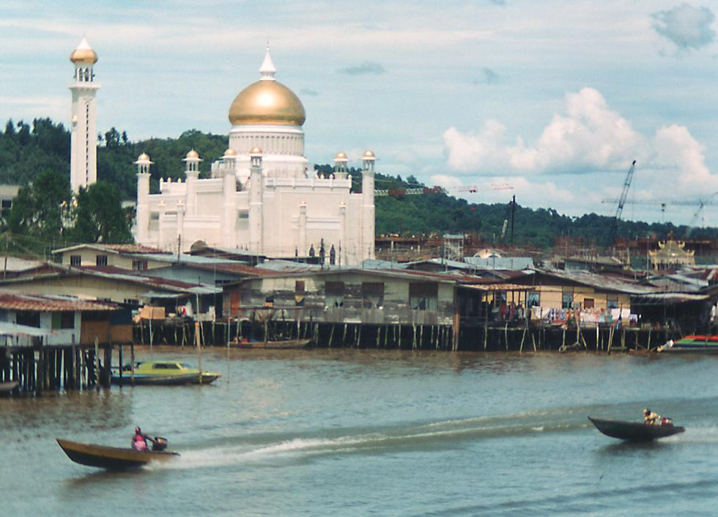
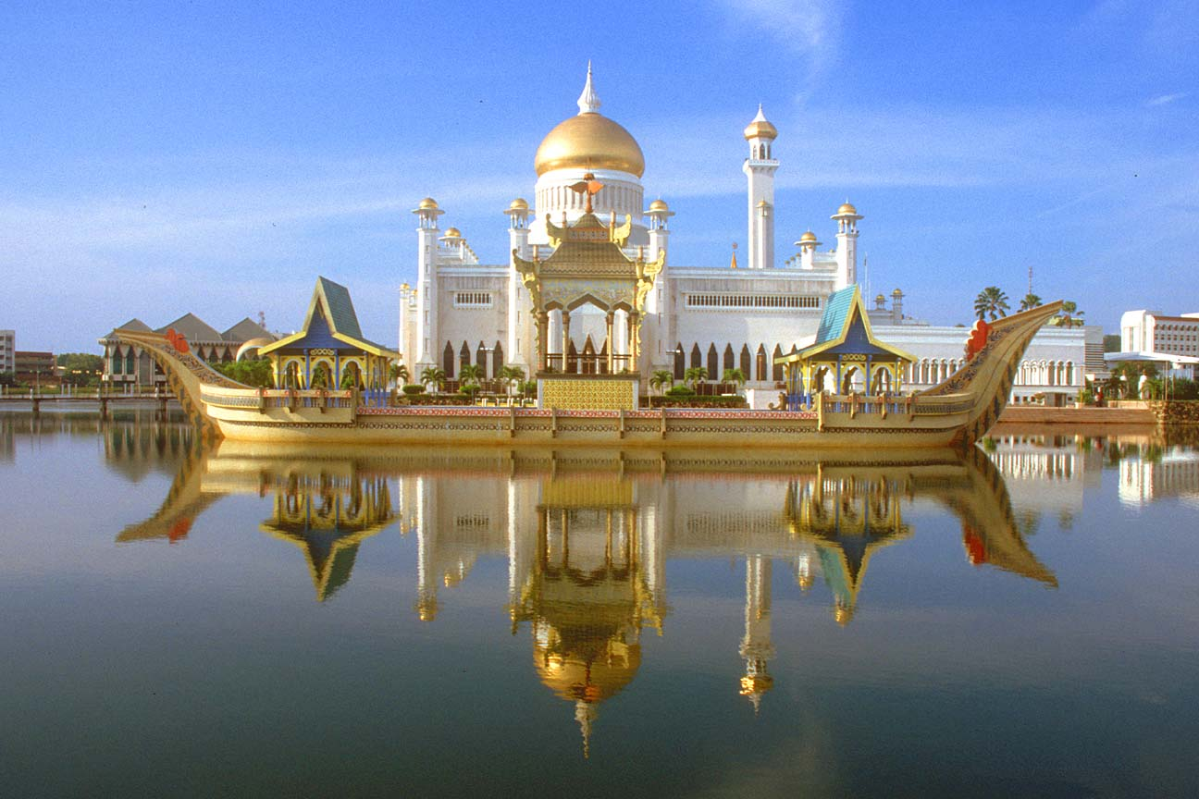

Jerudong Park Playground - Bandar Seri Begawan

North of Bandar Seri Begawan on the coast, Jerudong claims to be the largest amusement park in the world. Built by the Sultan of Brunei to mark his 48th birthday in 1994, all of the park's rides were originally free, but now have a nominal fee. The park is usually pretty quiet and it's unlikely you will encounter queueing even for the showpiece rides such as the Pusing Lagi or the Giant Drop. Obviously an ideal place to take children, there's enough to keep adults entertained too - and if you haven't got the family in tow a round of golf at the perfectly manicured Country Club course is a bargain for BND90.

Get to the park on the 55 or 57 purple buses from Bandar Seri Begawan's bus station, although do check return times. Alternatively, some hotels run quite pricey shuttle services to the park.

Open: Wed-Fri: 1700 hrs – 0000 hrs;
Sat: 1700 hrs – 0200 hrs;
Sun: 1600 hrs – 0000 hrs

Admission approximately: One Day Pass (unlimited rides) BND5, adults; BND3, children.

Omar Ali Saifuddien Mosque - Bandar Seri Begawan

An architecturally breathtaking monument to Islam, Omar Ali Saifuddien Mosque dominates BSB's skyline with its golden dome. Built in 1958 and named after the 28th Sultan of Brunei, the mosque is surrounded by its own artificial lagoon, which literally reflects its classic Islamic architecture. Within the luxurious but restrained interior of the mosque itself, a stunning Venetian mosaic made up of some 3.5 million pieces decorates the inside of its huge dome.

It's possible to take the lift or walk the staircase to the top of the mosque's minaret for a fine view over the city - ask permission first. The mosque is open to non-Muslims during non-prayer times: i.e. on Monday, Wednesday, Saturday and Sunday at 08h00-12h00, 13h00-15h30 & 16h30-17h30; and on Friday between 16h30-17h30 only. On Tuesdays and Thursdays the mosque is completely closed to non-Muslims.

Brunei Museum and Malay Technology Museum - Bandar Seri Begawan

Close by one another, these two museums afford an excellent overview of Brunei's history and development. The Brunei Museum showcases the country's cultural heritage and its Islamic gallery is the unmissable highlight, bringing together a stunning collection of beautiful artefacts from across the Islamic world.

The Malay Museum, just below the Brunei Museum on the river's edge, is dedicated to the country's traditional lifestyles and craftsmanship. This includes a fascinating gallery on the architecture of the water villages and how they have evolved over time, alongside impressive examples of Bruneian artisanship in brass working, silversmithery and weaving.

Both museums open: Sat-Thu 0900 hrs – 1630 hrs
Fri 0900 hrs - 1130 hrs & 1430 hrs – 1630 hrs
Admission: free

Batang Duri Iban longhouse - Temburong

Batang Duri is a traditional five-door Iban longhouse. These traditional buildings house entire villages within one large roofed space, with individual family rooms all adjoining a communal veranda. It's possible to visit the longhouse, meet the locals and wander some of the nearby jungle trails. Guests can stay the night on the veranda if they wish with meals provided - there are no fixed prices for doing so but offering BND15 or more for dinner, breakfast and accommodation will be greatly appreciated.

Batang Duri is situated in the largely undeveloped Temburong district of Brunei, which is physically separated from the rest of the country by a thin corridor of land belonging to Malaysia. Visitors need to first get a speedboat from Bandar Seri Begawan to the Temburong town of Bangar, a hair-raising but exhilarating journey through mangrove swamps and the open sea. Once in Bangar, it's a short taxi ride to Batang Duri. Passports should be carried in case Brunei police check the boat.

Ulu Temburong National Park - Temburong

From Batang Duri, it's possible to hire a longboat to go further upriver to Ulu Temburong National Park headquarters. The 90-minute river journey allows time to spot monkeys and birdlife in the virgin jungle on either side. Once at the headquarters, it's another hour's walk to the park's majestic Canopy Walkway, which lets hardy souls stroll among the treetops and provides excellent views of Brunei Bay as well as the surrounding countryside. Be warned that it's not for the faint-hearted or those scared of heights.

Amenities are provided at the headquarters but bringing extra provisions would be wise. Cabins are available to stay the night. Only accessible by boat.

Peradayan Forest Reserve - Temburong

Peradayan Forest Reserve, about 15 kilometres outside Bangar, has two sizeable hills, Bukit Patoi and Bukit Peradayan, which both offer scenic hikes through some beautiful countryside. Both have well-marked trails leading to the summits. The climb is steep in places but easy enough for anyone who is reasonably fit. Getting to the top of Bukit Patoi should take around an hour, and provides fine views of the sea and jungle. It's possible to follow the trail down the other side of the mountain and go on to Bukit Peradayan, which is about a three-hour round trip back to the road. Walkers should see plenty of birdlife, including hornbills, and perhaps a few nocturnal mammals if starting out early. For a small charge taxis will wait at the reserve's entrance for walkers to return, and it is advisable to take advantage of this service.

Tasik Merimbun - Tutong

The largest lake in Brunei, Tasik Merimbun provides a tranquil, picturesque place to take a picnic and enjoy a stroll through the nearby forest looking for monkeys and birds. There's a restaurant overlooking the lake for the supermarket averse. Getting to Tasik Merimbun is only really possible by car - the lake lies about 27km inland from the town of Tutong. The road is in very poor condition and badly signposted however so make sure of the way in consultation with a local guide before setting off - it is very easy to get lost. Better yet - hire a guide or taxi for the day if planning a trip here.

Pantai Seri Kenangan - Tutong

The presence of a holiday home built here for His Majesty the Sultan confirms that Pantai Seri Kenangan is Brunei's best beach. A few kilometres from the town of Tutong, the beach is often referred to simply as Pantai Tutong. A small spur of white sand makes up the beach, with the ocean on one side and the Sungai Tutong river on the other. Facilities are less than resort class, but there is a small restaurant where you can get a drink and something to eat. Locals tend to bring their own picnics. Getting there is difficult without a car - there is no public transport available. The turn-off to reach the beach by road is near the Tamu Tutong.

Brunei Bay Diving

Brunei's best attraction is undoubtedly the beautiful waters of the South China Sea and sheltered Brunei Bay provides the perfect environment for oceanlovers. There are some spectacular wrecks for scuba diving enthusiasts off the island of Palau Labuan. The four main wrecks in the bay date from the age of exploration to an American World War Two minesweeping vessel - the USS Salute, sunk by a Japanese mine in 1945. The bay also has several areas of coral reef, including two artificial reefs made from sunken oil rigs. These are now home to a stunning variety of soft corals as well as rays and sharks - including the massive but harmless whale shark (the largest fish in the ocean).

LIST OF INDIAN RESTAURANTS IN BRUNEI:

- Le Taj
Bandar Seri Begawan, Brunei
Ph: 2238996
- Sagar
Bandar Seri Begawan, Brunei
Ph: 2333718

